1. Use Selenium IDE to record a test that hovers over the 'Categories' menu on the Flipkart homepage and verifies that the dropdown appears.
Ans=> 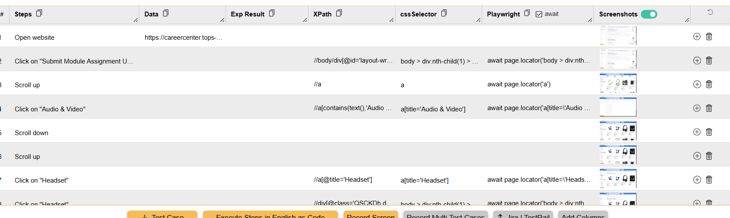

2. Install the 'UI.Vision RPA' Chrome extension and create a macro to perform a drag-and-drop operation on https://jqueryui.com/droppable/ by dragging the draggable box into the drop area.<br><br><em><strong>Hint:</strong> Use the extension's visual UI to select and move elements.</em>
Ans=> 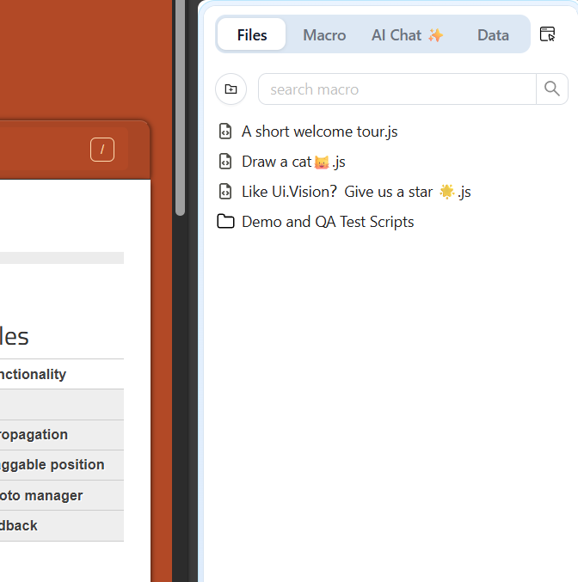
3. In Selenium IDE, automate a scenario where you use keyboard shortcuts to search for a product on Myntra: focus the search bar, type 'shoes', and press Enter to trigger the search.
Ans=> 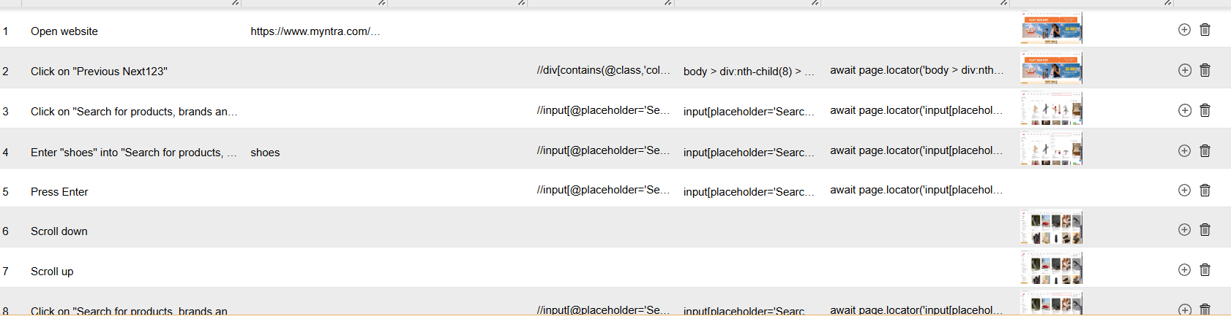

4. List 3 limitations you faced while trying to automate hover or drag-and-drop actions using only Selenium IDE or Chrome add-ons, and briefly explain how these limitations might affect testing real-world web apps.
Ans=> Complex mouse interactions may not work reliably
Hover menus and drag-and-drop often require precise mouse movements, intermediate positions, or chained actions. Selenium IDE/add-ons may not reproduce these interactions exactly like a real user.
Dynamic elements can be difficult to target
Hovering may cause hidden menus or elements to appear dynamically. Their DOM structure, IDs, or CSS classes can change after the hover.
Limited control over advanced actions
Basic record-and-playback tools provide less control over low-level mouse actions than full Selenium WebDriver APIs. Complicated drag-and-drop operations, such as dragging an item into a specific location, can therefore be difficult to automate.

5. Use Selenium IDE to automate navigating the Zomato website's menu: hover over the 'Order Food Online' section, click on a cuisine (e.g., 'Pizza'), and verify that the results page loads.
Ans=>
Ans=> 